WELCOME TO CS-521!!!

Tue - Thu, 6-7:30 p.m.

Lecture 6 (Nov 19, 2020)

Week 3:

Homework 3

Quiz 3

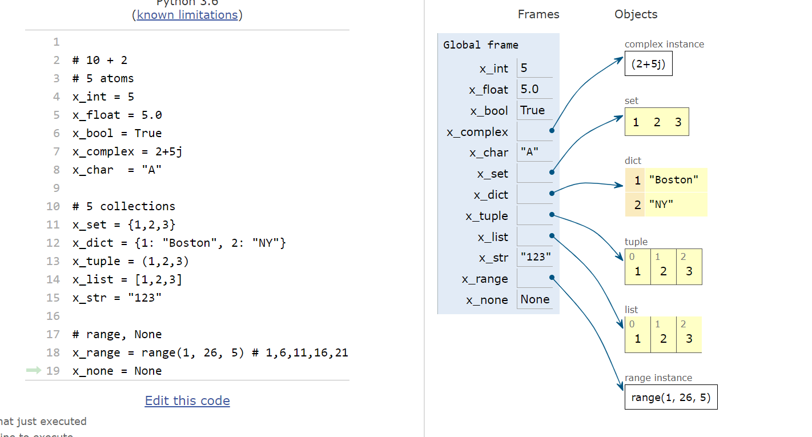

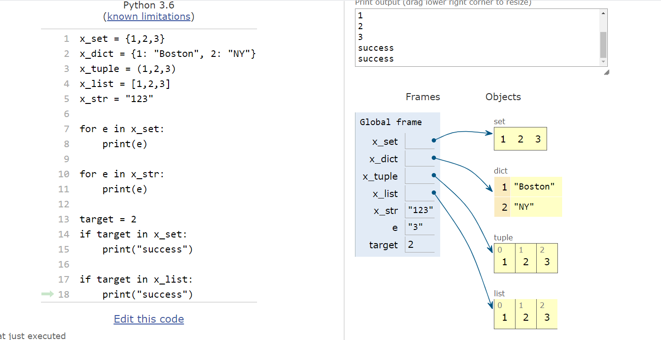

python sets cannot contain mutable elements

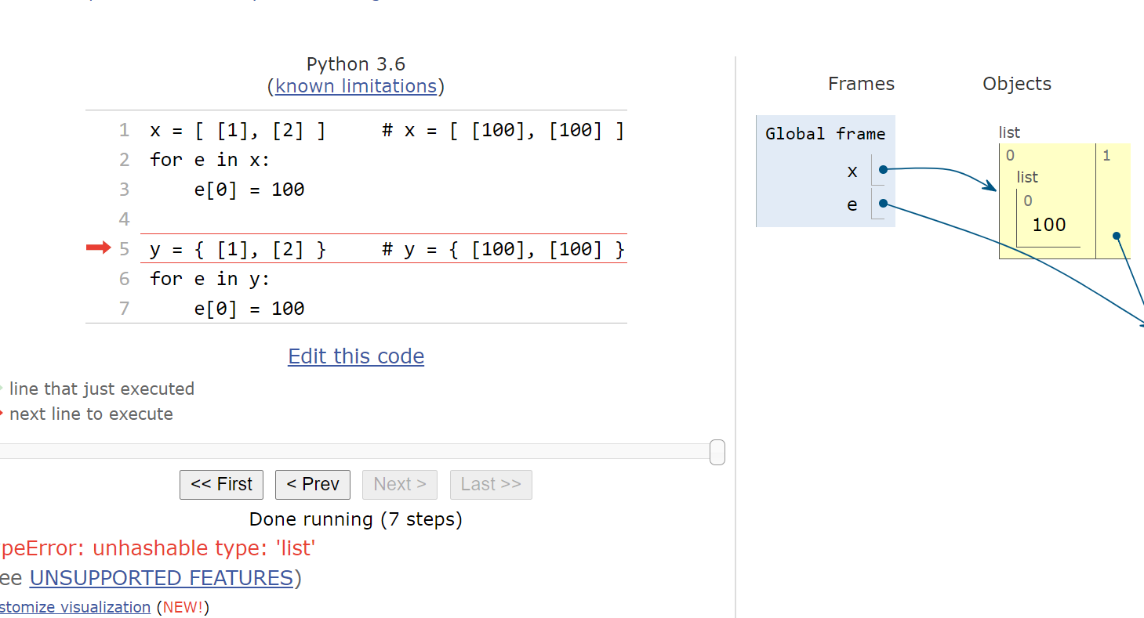

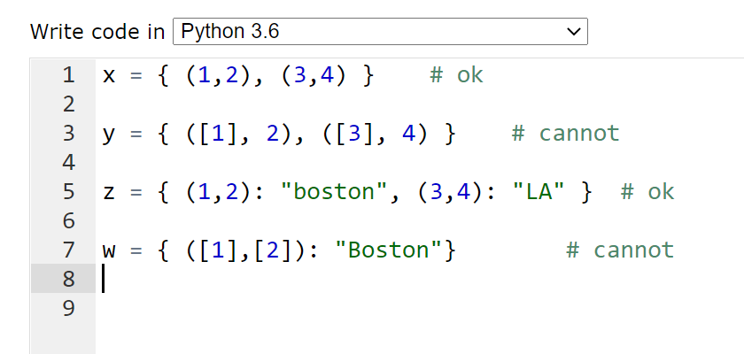

Characters are encoded by integer values

1. ASCII (Amer. Standard Code for Information interchange)
2. EBCDIC

1 byte per character (8-bits)

0 --------🡪 255

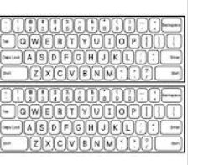

26 alphabetical x 2

10 digits + 10

255 was enough

Variable length encoding

Why?

1. many new alphabets

Why variable length encoding:

1. two symbols a and b
2. a is 99% b is 1%

Alternative 1: 2 bytes per char

1000 charcters -----🡪 2,000 bytes to store

Alternative 2: 1 byte for “a”, we use 3 bytes for “b”

990 char x 1 bytes + 10 char x 3 = 990 + 30 = 1,020

idea: use fewer bits to represent more frequent letters

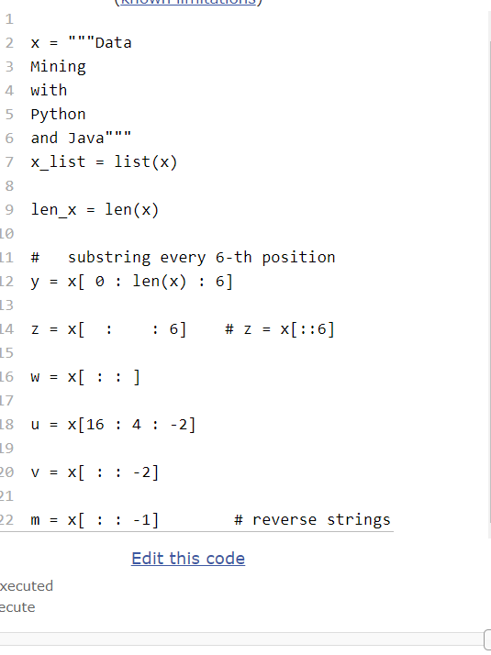

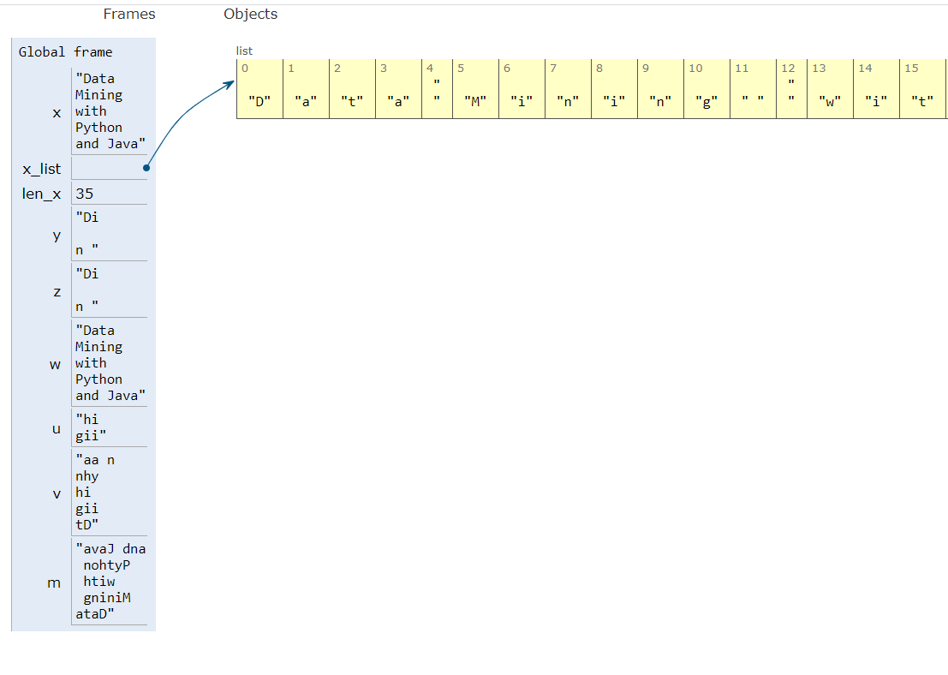

Q: detect if string x is a palindrome

dad, racecar

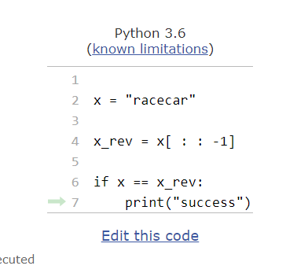

reverse list or tuples is the same as strings

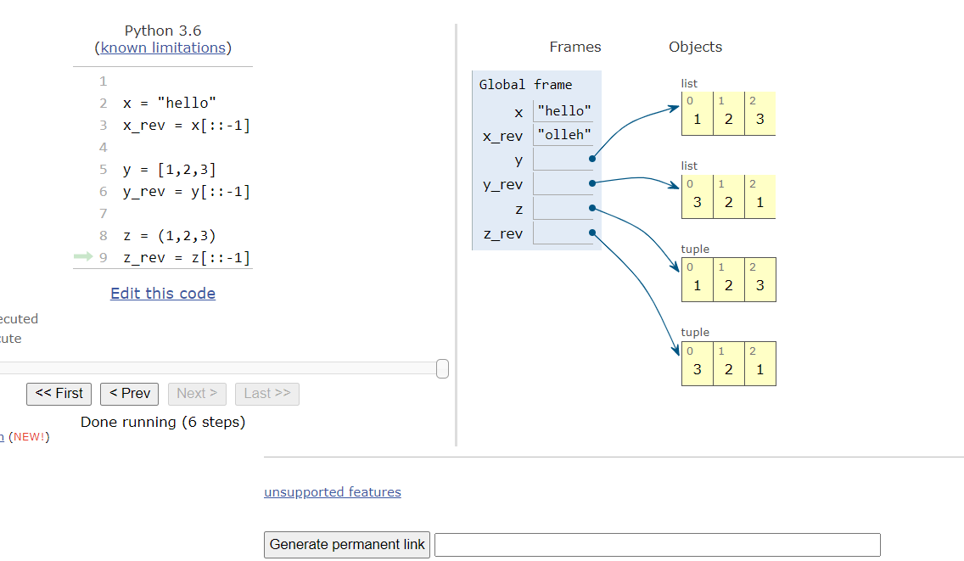

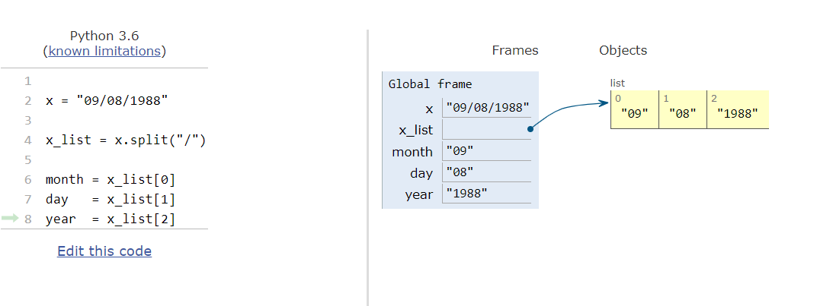

strings are immutable and there should be a single copy of any string

but …. it is possible to construct examples where this is not the case

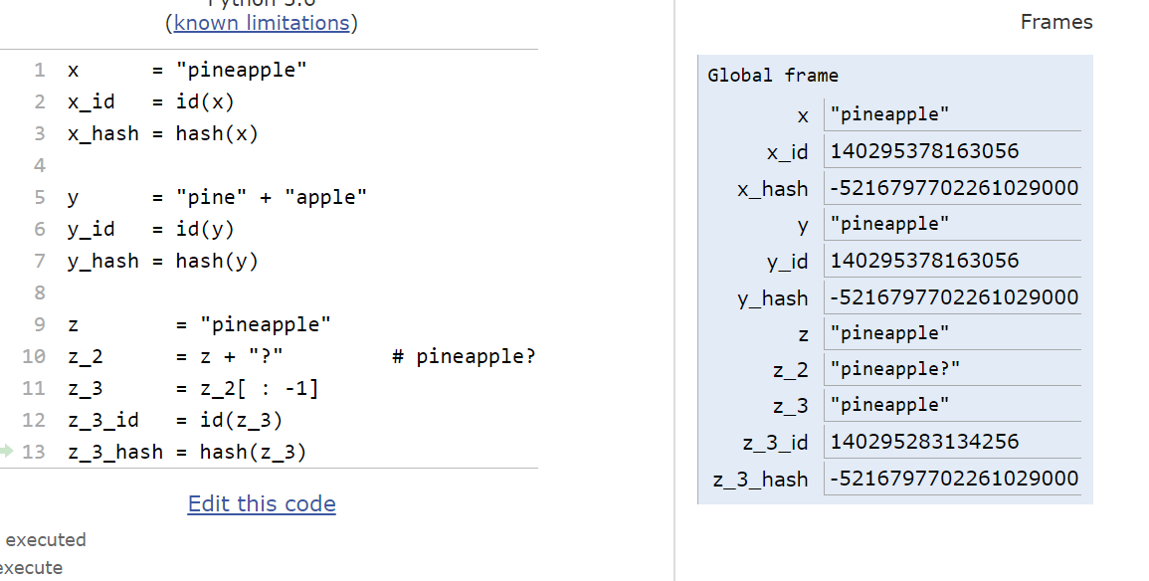

strings: collections (“molecules”)

ordered collections (char are at specific index positions

* indexing and slicing
* many methods
* immutable (often you would convert strings into lists, do processing on individual list elements and then combine list elements back into a final strings.